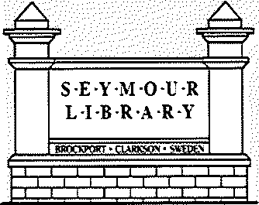
Seymour Public Library Serving Brockport-Clarkson-Sweden NY

2022 created opportunities for growth and identity refinement.

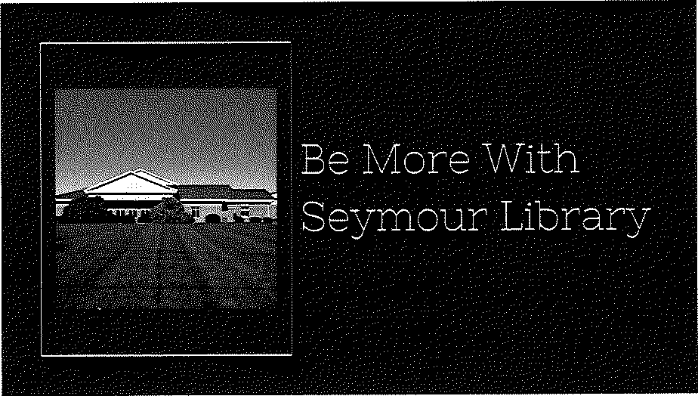
Seymour library Mission: Lifelong learning and discovery for all.

Seymour Library Vision:
Provide a safe and inviting community gathering space in the Library.

Build meaningful community connections.

Serve as community technology hub, facilitating access and instruction.

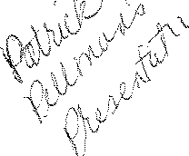
Maintain robust program offerings, increase the size and scope of physical and digital collections.

The library began operating at a more normalized capacity in 2022. 1

Seymour Library Core Values
S·E·Y·M·O·U·R L·l·B·R·A·R·Y

Intellectual Freedom
Support intellectual freedom and free
. .
InquIry.

Education, literacy, and lifelong learning
Meet community needs by promoting lifelong learning and literacy in all forms.

Access
All information resources are equitably accessible to all Library users.

- Resources to help patrons discover information for both imposed inquiries and intellectual curiosity. Reference Questions: 8,124

- Diverse collections and programming to teach new skills using engaging methodology, enhance current knowledge,
acknowledge multiple literacies,
-•-•-•w~•"-•~----·•"'-•----'-•-·'"" "·,-,.,_.. _{,+"'} ""·••·-
and begin understanding civic engagement.
" Maintaining the library as an institution of knowledge, wherein the use by one patron does not disrupt or diminish the usage by another. ²

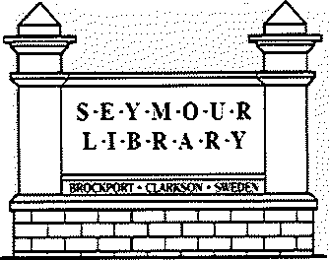
Seymour library Core Values

Confidentiality/Privacy
Protect everyone's right to confidentiality and privacy.

Service
Provide the highest level of customer service to all Library users.

Sustainability
Commitments to practices that are environmentally sound, economically feasible and socially equitable.

3

Library Usage Trends

S·E·Y·M·O·U·R L·I·B·R·A·R·Y
,F;;wf(if'I

library Usage Increased in 2022 As Normalization Returned
Note: A 3-year rolling average illustrates the rebound in library usage and circulation post-Covid

92

556

2,613 5,309 8,946 24,635 57,092 126,846

53 198 1,274 2,825 3,365 14,970 31,312 91,866

Displays and Meeting Exhibits Room Use
Open Hours Computer Interlibrary - Interlibrary - library Log-ans by Loaned Borrowed Visits/Door
Annual Circulation

Patrons

2020 2021 2022
Counts
(includes curbside)
4

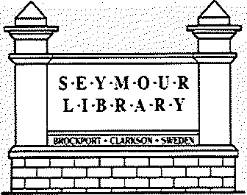
Library Use: Successes in Circulation

Circulation 2022:
The incorporation of professional staff with practical knowledge of collection development made an increase in circulation possible. Percentage change from 2021.

20

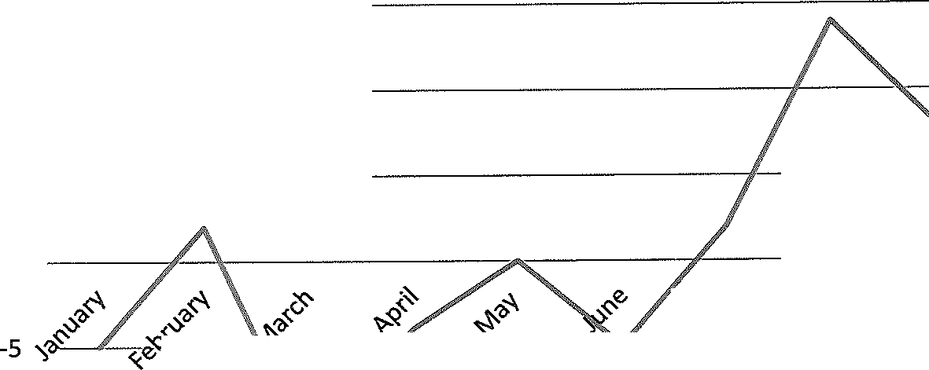
15
10
5
0
,·
,..
T
,,,
JY
', --.
...._.s
-,"
(!f'

:.oe
.,, o
:.oe

:.o=
:.o=
c,e'Q
...
0 <-
o
,:,.
Qe
c'-
, _
-10

-15
-Circulation by month

5

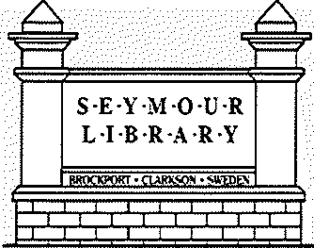
Circulation: What Did We Hear?

Q6: What is the primary reason for visiting the library?
A'.".s·::2,.2:: 5S S'.<:;:::2:: S

:..i ,; ;..; 1.., ' •::;''""''" ,._1.,1, ....
"'u rro·1M hoo·K._{C:} or a'io-it?i m.orli?.

Access to research & study
mat. en.a1.s
; i.)..'",,,_ '~-,Vnac,J-i:,-n,' u.i._.o.,,r_c, ._, ·O· Ir "J 1b' r':-o'' n/.,.,

,]nI-l';J"='--'rson1 t ; oirnVe• craaf;',\,,;..

2.32%

2.32%

6.60%
77.18%

Comments within the survey pointed to favorability in how patrons perceived the library, overall sought more diversity the collections with more choice in books.

0t.
r .j Q.!;O s c:oerp-1-r' )

'- ;,_, \, , ........ ,_ ""1 '-- ''j 1
11.59%

:¼ ::;:-; 2::s-; 3: ; .:.::;; s:s; ::;; ;c: s:;,-; sc:,: ::::,;

6

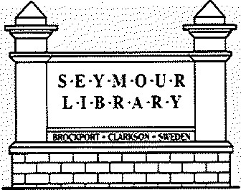
library Circulation: What Did We Do?

Circulation 2022: Steps We Took

- Emphasis on outreach to bring awareness to collection development. The Oliver Middle School and Brockport High School outreach events netted over 500 interactions with students at each school.

- Consolidation of parts of the Children's collection to increase ease of use and accessibility.

  - Creation of the Tween {Middle Grades) collection.

  - Hiring of a permanent Adult Services librarian with a background in developing collections.

  - Established the Baby Dragons program and brought 1,000 Books Before Kindergarten to Seymour.

7

Library Circulation: What Did We Do?

S·E·Y·M·O·U·R L·I·B·R·A·R·Y
•CW!K.<;ON•<;!']

Circulation 2022: A Granular look
An example of one collection created and curated in 2022. The Middle Grades/Tween collection did not exist before February 2022. It contained a total of 815 items in December 2022. This represents Tween circulation in 2022:
February 2022: 19 circulations, 30 items in collection 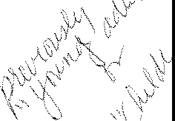
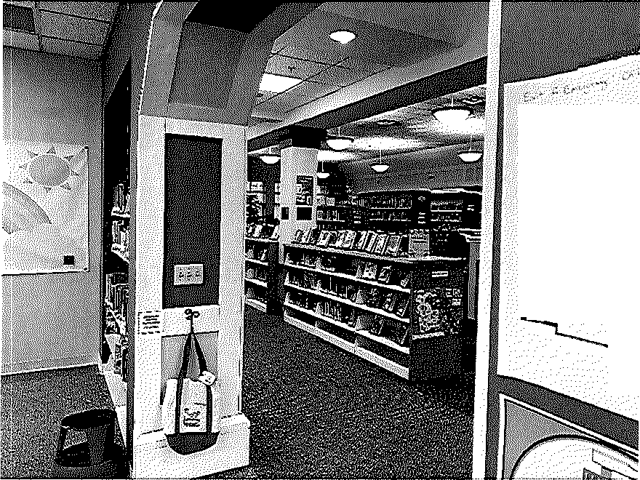
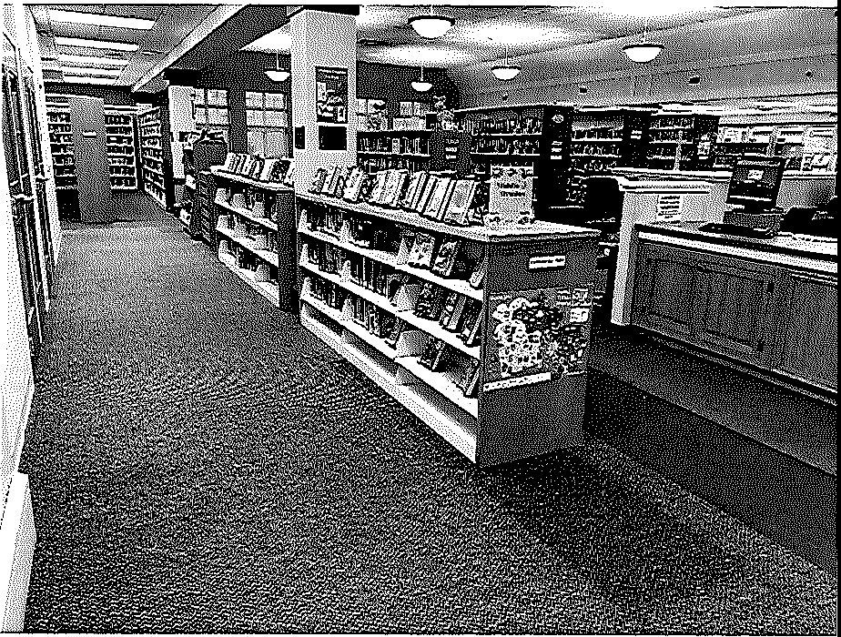
December 31, 2022: 1,192 circulations, 815 items in collection
tj;;;;,.{
ftfqnl
.
1111111111[
- '
lllli ill

8

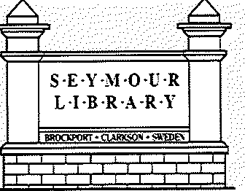
Library Use: Door Count/Patron Visits

Door Count by Month 2022: At 57,092 patrons with 2,613 open hours, we served about
22 patrons. per hour in 2022.

January | 3,212 | January | 2,270
February | 4,204 | February | 2,670
March | 4,632 | March | 3,127
April | 4,856 | April | 2,940
May | 4,204 | May | 2,650
June | 5,338 | June 3,966
July | 5,601 | July 5,336
August | 5,752 | August | 4,385
September | 4,290 | September | 3,499
October | 5,455 | October | 4,334
November | 4,444 | November | 3,829
December | 5,104 | December | 3,582

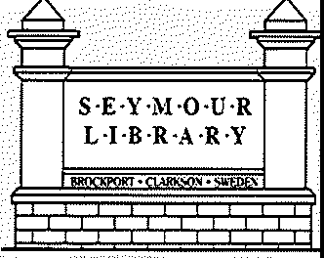
Door Count 2022: Thinking Forward
library Visits: What Can We Do?

·-,-<,.

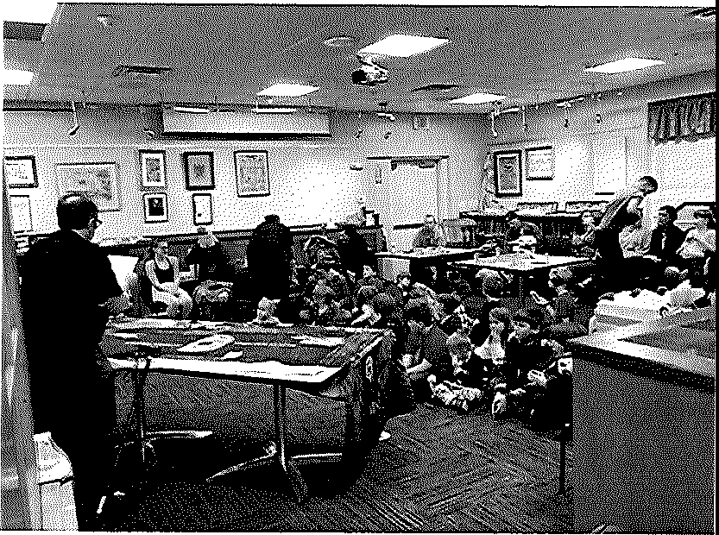
- Find new methods to track patron usage of the
building.

-".

Create dynamic crossover
programs.

- Maintain flexibility at the 53-hour budgeted weekly hours.
- Continue asking questions. 10

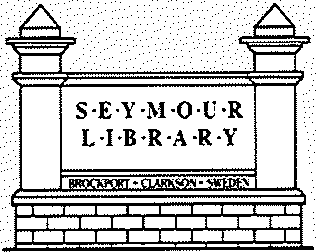
2022 Program Trends

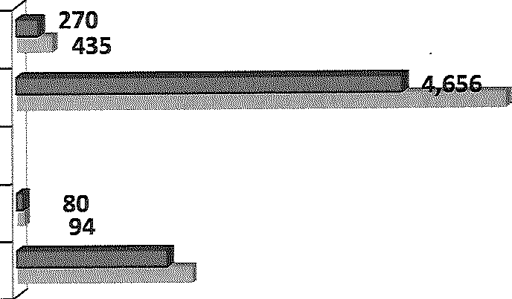
Children and Young Adult Programs/Participation Decreased in 2022
1,820
2,123

Children Programs Children Participation

Young Adult Programs Young Adult Participation

5,911
112022

2021

;

Early literacy and Adult Programs/Participation Stabilized in 2022

_,.,
Early Literacy Programs J a'l!I igg
;
79
. \ii 66

Early Literacy Participation

Adult Programs

llt

112022

2021

Adult Participation
1M IIIIIIIIIIII 93
_b\i,,1aii 11m01!:l•• - ,1 111llli•111111!:1!!11!:\\ l!'.l!cl, 765
11

Programming: What Did We Hear?

S·E·Y·M·O·U·R L·I·B·R·A·R·Y

COMMUNITY NEEDS-EXTREMELY IMPORTANT RANKING

1. Children & youth programs | 59.86%
2. Education & lifelong learning | 40.11%
3. Technology | 31.90%
4. STEM | 30.00%
5. Access to social services | 24.82%
6. Financial literacy | 22.22%
7. Arts, culture & leisure programs | 21.58%
8. Volunteer opportunities | 17.12%

The community wants to see the library offer more in the way of fun and educational programming for the youth within our area.

12

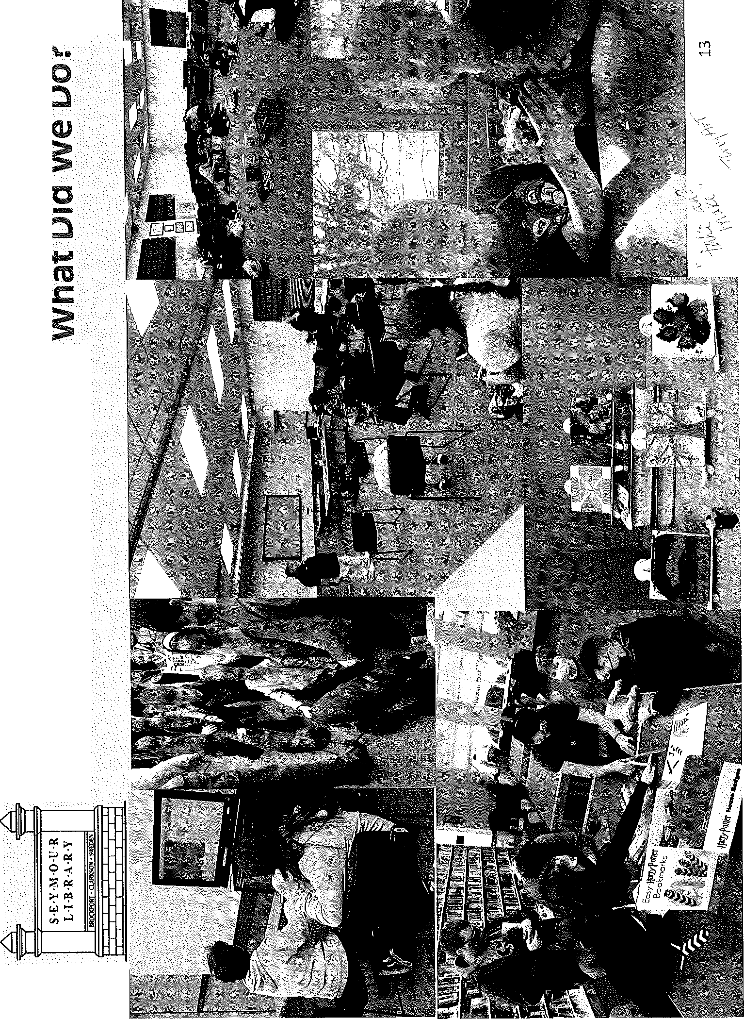

•c•o
·C-:
E

E
.n..:.,
co
0....
0..

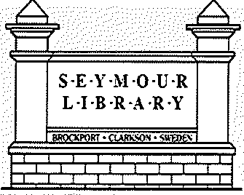
Programming: Underpinning Literacy

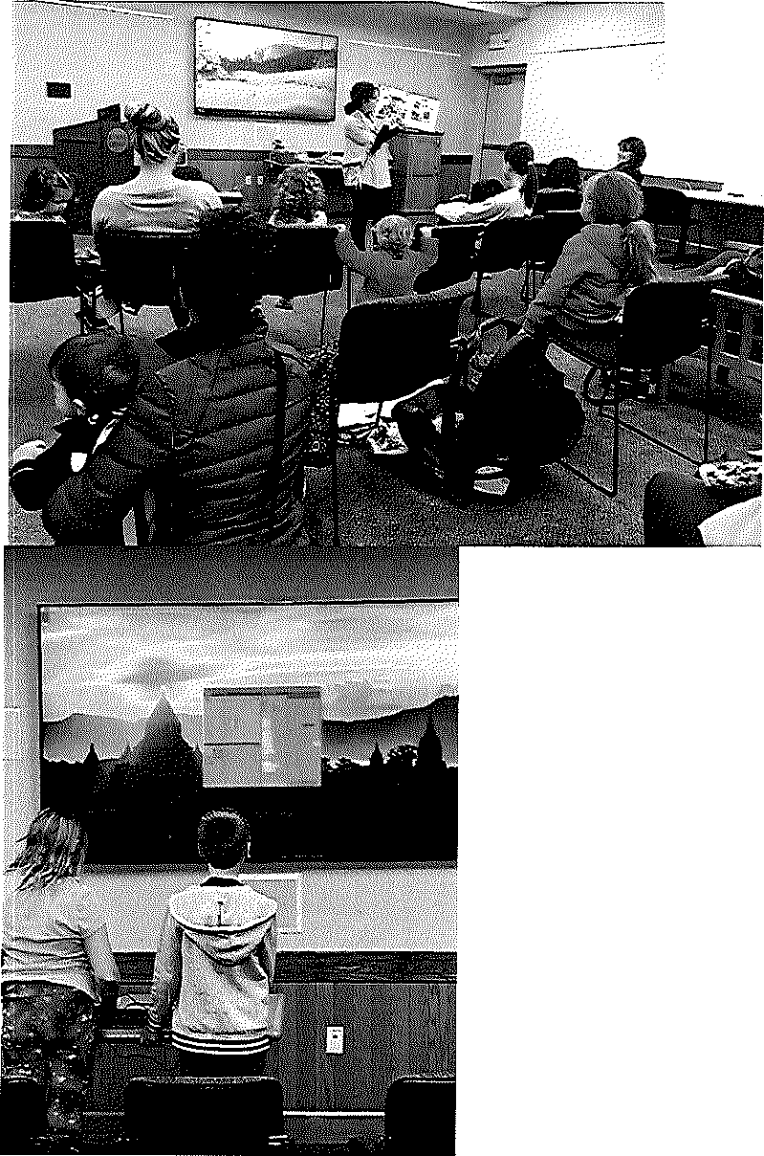
-----·.. •

"I

Local author visits and story times kept our youngest patrons engaged with basic reading literacy.

1000 Books Before Kindergarten and Baby Dragons incentivized families to borrow library books and read to, and with, their children.

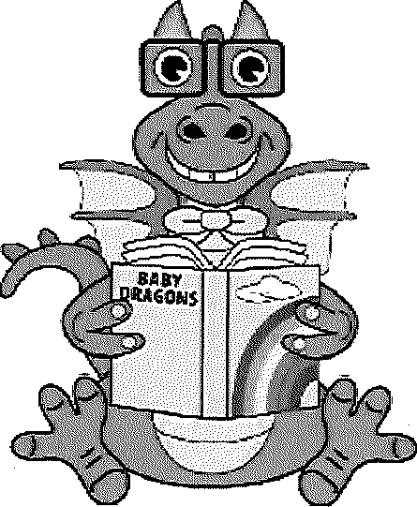
Digital and technological literacy programs enhanced the knowledge and inquisitiveness of our Teen and Tween patrons.

One on one computer education classes helped start bridging the digital divide within the Seymour community.

14

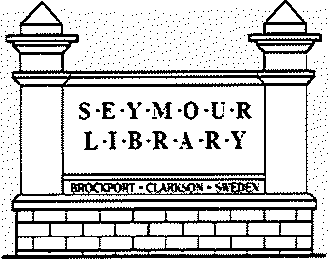
Summer Reading: What Did We Do?

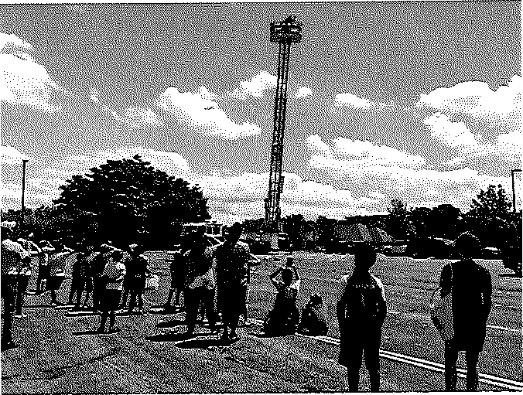
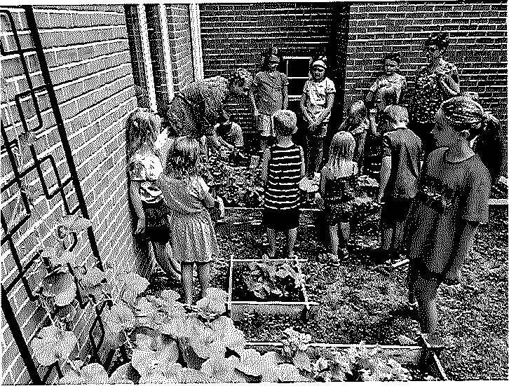
The librarians worked to incorporate multiple learning styles into the summer reading program.

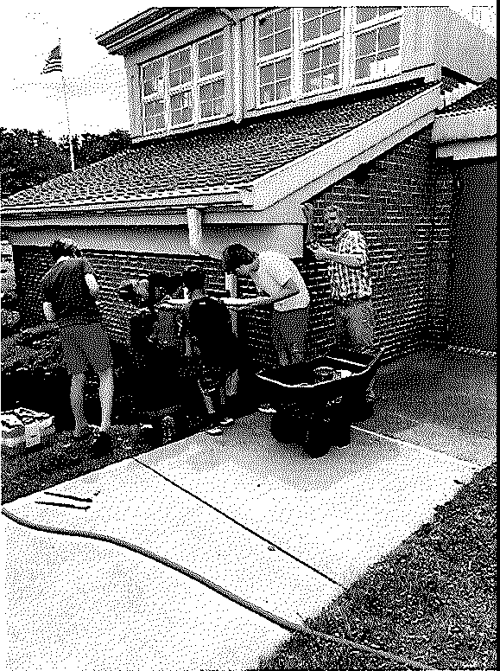
The librarians also collaborated to feature books tying into each w eek1 s theme.
15

Challenges Faced in 2022

S·E·Y·M·O·U·R L·I·B·R·A·R·Y

4.5

4

3.5

3

2.5

2

1.5

1

0.5
Budgeted Professional Employment FT 2022

0
;;l<. ;;l<. ?S"

i..

..,.§e' ,
..,-s- vc}­ 2P

'>'?,' "' -;..°"' ,§,
'<;;5)
'1?-v¢c
'&#.e
c.,e-

o<'i-
,.#e
o

c,'li
<:f

Ill Children's 1111 Adult lll1 YA lII Director
#

16

Challenges Faced in 2022

S·E·Y·M·O·U·R L·l·B·R·A·R·Y

4.5
4
3.5
3
2.5
2
1.5

1

0.5
0

Professional Employment FT 2022, Actual

rl>;;\. rl>;;\. o'
','l>""' ' !..v ,§-
'-<.
i. e,
',°""'
', ._,o/
"?-°"¢o c-..e
c,e

:$;i
0 o,:{l- e e
c-0

II Kim II Jennifer iil!i YA II Adult II Director Interim

17

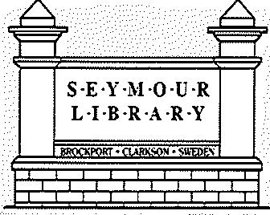
Staffing in 2022

Director | 2,080 | 1,600 | 77%
Children's | 2,080 | 1,040 | 50%
Children's 2 | 2,080 | 880 | 42%
YA | 2,080 | 2,080 | 100%
Adult | 2,080 | 1,560 | 74%

18

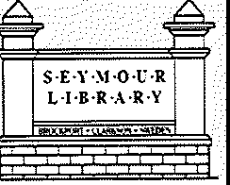
2022 Operating Results

2022 Revenue: $710,735

25.9% - Brockport Funding
($184,433)

  - % - Clarkson Funding
($179,255)
2021Expenses $542,202

64% - Payroll and Benefits
($346,527)
Examples of Non-Payroll

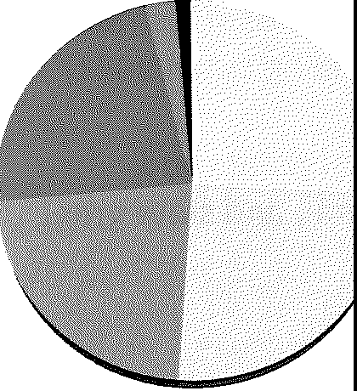
Ill! 22.4% - Sweden Funding
($159,378)

Examples of Other Revenue

Ill! 22.5% - Gifts, Endowments, Donations ($160,211)
1111 2.6% - Fines, Fees
($18,537)

    - 1.2% - State Aid {$8,193}

Ill! .1% - Interest ($678)
Ill! 12% - Operation and Maintenance of Building ($64,199)

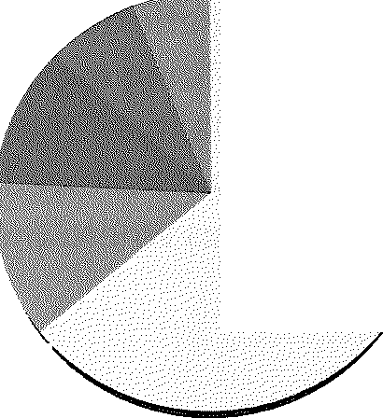
Ill! 11% - Print and Electronic Material, AV, Book Processing {$61,252)

Ill! 7% - Miscellaneous Expenses, Supplies ($39,018)

Ill! 6% - MCLS Cost Share
{$31,206)

19

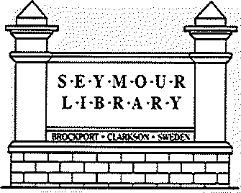
2022 Goal Accomplishments

Strategic Area One: Develop a long-term Sustainable Funding Strategy

2022 Goal Accomplishments:
- The Dorcas Michaels bequest netted the library additional revenue above and beyond the anticipated budget. These funds will help develop the library in other strategic areas, though, not necessarily solve the issue of long-term funding.
- As always, the Friends of the Seymour library and the Seymour Library Foundation went above and beyond in their fundraising efforts to build the library toward a fully operational institution.
- Resetting to 53 hours and stabilizing regular hours also brought back the funding cut in 2021, thereby improving the functionality of the library.
- Relationships with area merchants allowed for the possibilities of future local grants and identifiable needs pinpoint areas where the library can utilize national, federal, and state grant monies most effectively.

2023 Next Steps:
- The 2023-2025 Long-Range Plan seeks to increase the efficiency and utility of all funds received to benefit the community.
- In assessing the success of the previous LRP, we may need to collectively evaluate whether we have a collective funding model that works to bring library expenses and revenue to a net zero.
- Begin grant applications for larger range projects, such as a Makerspace, refurbishing the Children's Room, and finish using the DASNY grant for internal maintenance and upkeep. zo

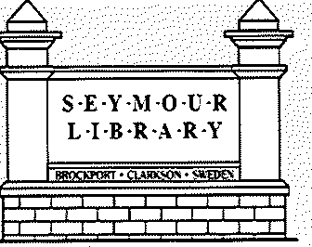
2023 Goal Accomplishments

Strategic Area Two: Strengthen Communication with Stakeholders and Community
2022 Goal Accomplishments:
- Engaged the community and community leaders by creating experiences in educational events and celebrations including Summer Reading Program, Kiwanis Bookmark Contest, and Silver Anniversary Celebration.
- Fostered user engagement by scheduling programs and presentations to meet patron needs in both the large meeting rooms and the quiet study rooms.
- Began creating connections with SUNY Brockport in order to draw more patrons in our service area and create stronger connections to the community.
- Formed relationships with the Brockport Merchants' Association and local businesses in each of the municipalities.
2023 Next Steps:
- Continue outreach efforts in elder care facilities and with SUNY Brockport. Expand the outreach efforts to Brockport Central School District and within the municipalities to facilitate connectedness.
- Begin adopting marketing targeted to a wide net of the population, both print and digital.
- Identify the strong points of the Seymour brand and begin leaning into those elements more publicly.
- Use formal and informal feedback from patrons to improve quality of programs and collections in real time. 21

2022 Goal Accomplishments

S·E·Y·M·O·U·R L·l·B·R·A·R·Y

Strategic Area Three: Create an Attractive and Welcoming Environment That Fosters Use of a Commons (a community space within the library for intellectual growth and positive community relationship development)
2022 Goal Accomplishments:
  - Jennifer contracted with Safari Landscape to touch up the gravel and vegetation on the property. An excellent start to an issue patrons identified as a need for the library.
  - The Teen Art Wall exhibits
  - Continuous displays on the circular shelving.

2023 Next Steps:
  - Continue developing the collections to make the shelves and books more appealing and accessible to the public.
  - Internal upkeep projects, including painting, carpeting, and bringing an overall aesthetic of modernization and cleanliness blended with the traditional elements of what makes Seymour unique.
  - Maintenance and effective utilization of the grounds to create attractive curb appeal.
  - Ensuring patron comfort in furniture arrangement and location to maximize ergonomics and invite patrons to stay in the library.
22

2022 Goal Accomplishments

S·E·Y- f-O·U·R
L·I·B·R·A ·R·Y
•.!!!]

Strategic Area Four: Enhance Technology Infrastructure and Accessibility
2022 Goal Accomplishments:
  - Began technology programs focused on learning programming languages and basic coding.
  - Acquired Raspberry Pi kits from the Central Library to continue offering digital literacy programs to all ages.
  - Installed audio-visual information system at the circulation desk for more practical, patron
focused digital signage.
  - Brought Ancestry Library Edition and PrinterOn software to increase database and printing access for all patrons.
  - Developed updates and upgrades to our website.

2023 Next Steps:
  - Continue Library's use of emerging technologies to deliver services, focusing primarily on Maker technologies and practical skills.
  - Expand Digital Literacy with in-person lecture tech workshops to begin closing the digital
divide. Utilizing Ben and Leslie for tech signups one-on-one, drop in, on-demand accessibility.
  - Provide promotion and training of electronic services (e.g., Libby Electronic Audio Books)
  - Evaluate technology infrastructure and accessibility and determine next steps for delivering quality hardware and software for patron usage. 23

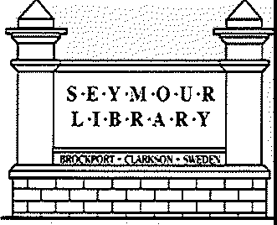
2022 Success Summary

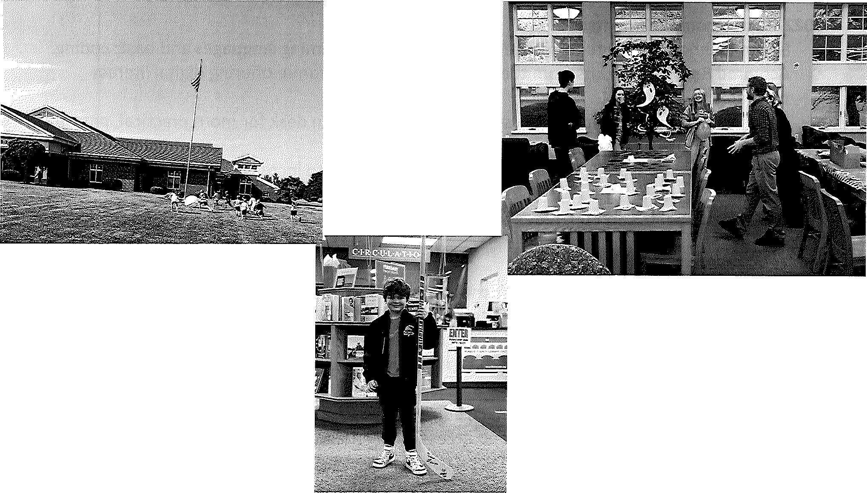
Though 2022 presented many challenges, overall, it was a successful year!

Fulfilling the mission of the Seymour library in practice.

Created engaging programming and areas of interest increasing foot traffic and circulation.

Working with our community supporters and assets to round out volunteer opportunities to increase stakeholder engagement.

24

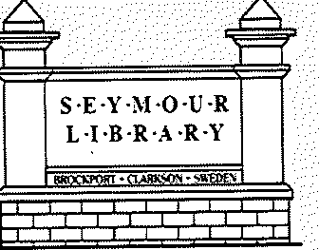
In Closing: Why Do We Do It?

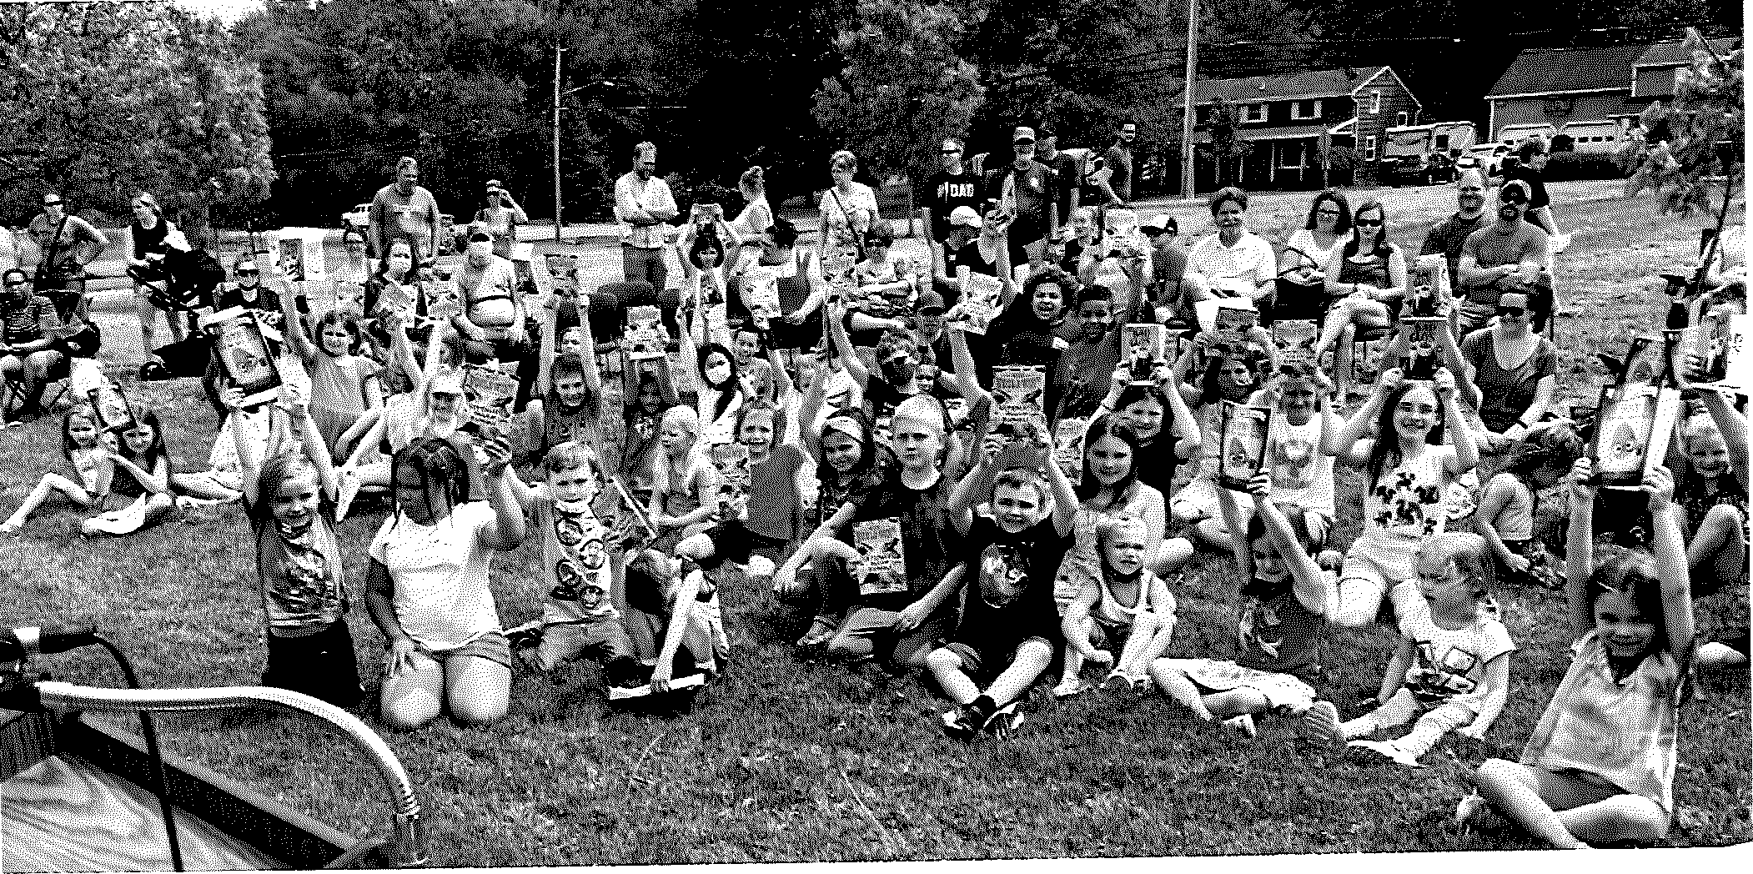
25

2022 Trustees | 2022 Staff | Foundation | Friends
Officers: | Library Director: | Mission: | Mission:  The Friends advocate for the Seymour Public Library and support library collections, services, programs and staff development.  The Friends Provide: Program Refreshments, Fees for the Library Website, Book Page Review Magazine, VIP Discount Passes for Rochester Attractions and Library Equipment.  Officers:  Lynne Gardner  President  Laura Buckner  Vice President  Barb Gifford  Secretary  John Hamling  Treasurer  26
Bernie LoBracco  President | Jennifer Caccavale through 9/22 | To seek contributions in order to  enhance the Seymour Library for
 | Children Services librarian: | patrons; provide a vibrant space to
Marilynn Brown  Vice President | Kim Whittemore through 6/1/22 Jennifer Silmser 6/26/22- | share resources and ideas; and to  explore and experience the power and pleasures of lifelong learning.
Scott Maar  Finance Officer  Dr. Scott Rochette  Secretary | Teen Services Librarian:  Patrick Pittman  Adult Services librarian: | Officers:  Carol Gravetter  President
Trustees: | Lea Takigawa 2/22-7/22  Leslie Boedicker 10/22- | Lynne Gardner  Vice President
Libby Caruso  Dr. Patricia Galinski Dr. Bruce Leslie Kristen Sharpe | Part Time library Clerks:  9 Clerks filling PT positions (avg) | Donna Mancuso Secretary  Mary Marone  Treasurer
Treasurer:  Kevin Johnson, Town |  | Non-Voting Members:
of Sweden Supervisor
 |  | Library Director
 |  | President, Library Board of Trustees

